Type Title of Your Paper Here (Palatino Linotype, font size 14 pt., bold and centered, initial letters should be capital)

Name Surname, Name Surname, Name Surname

*Corresponding author’s email address
(Palatino Linotype, font size 10 pt., italics, centered)

Abstract

A concise and factual abstract (200-250 words) should state briefly the purpose of the research, the principal results and major conclusions. An abstract is often presented separately from the article, so it must be able to stand alone. For this reason, References should be avoided, but if essential, then cite the author(s) and year(s). Also, non-standard or uncommon abbreviations should be avoided, but if essential they must be defined at their first mention in the abstract itself.

Keywords: should be 4 and 6 at least and at most, and separated by semicolon.

1. Introduction

Palatino Linotype 10-point normal font with single spacing must be used in writing. A single space must be left between paragraphs. The text should not be more than 15 pages including all figures, tables and references.

In the introduction of the article, the importance of the subject and its justification should be explained. In addition, general information should be made on the subject and the importance of the article should be given by making a literature review on the subject.

2. Material and Method

All headings must be in bold character and numbered consecutively. Material and method section should be given information about the materials used in the study. In addition, the experiments and analyzes applied to the produced samples should be explained in this section.

2.1. Material

Figures and tables must be cited in the text. Figure and table captions should be in Palatino Linotype 10-point normal font.

Table 1. Table caption
Number | FS (MPa) | CS (MPa) | Porosity (%)
AF1
AF2
AF3
AF4

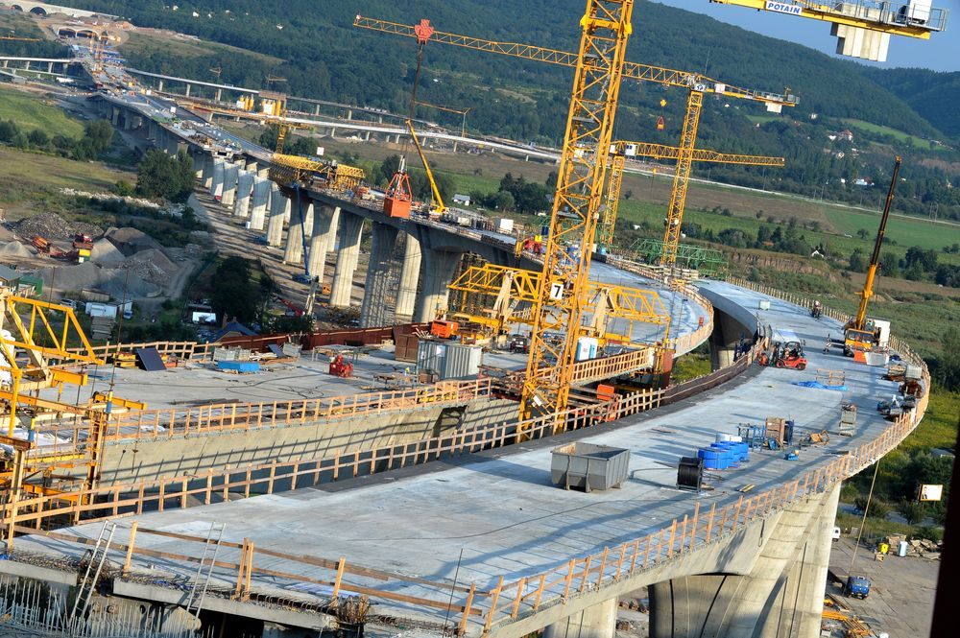
Figure 1. Figure caption

2.2. Method

Each equation should be presented on a separate line from the text. The equations should be right-numbered in consecutive order.

$f\left(x\right)=a_{0}+\sum_{n=1}^{∞}{\left(a_{n}\cos{\frac{nπx}{L}}+b_{n}\sin{\frac{nπx}{L}}\right)}$ (1)

2.3. In-Text references

For references, use author’s last name and year for one author, both authors’ last name connected with “&” and the year for two authors and first author’s last name followed by et al. for three or more authors.

3. Results and Discussion

Palatino Linotype 10-point normal font with single spacing must be used in writing. A single space must be left between paragraphs.

3.1. Physical Properties

Palatino Linotype 10-point normal font with single spacing must be used in writing. A single space must be left between paragraphs.

3.2. Mechanical Properties

Palatino Linotype 10-point normal font with single spacing must be used in writing. A single space must be left between paragraphs.

4. Conclusion

Palatino Linotype 10-point normal font with single spacing must be used in writing. A single space must be left between paragraphs.

Acknowledgements

If no acknowledgement is necessary, this section should not appear in the paper.

References

Endnote APA 7 format should be used in in-text references and in the writing of the bibliography, and the spelling rules of the journal should be carefully examined. References should be given as aphetically order.

​Global warming. (2009, June 1). Retrieved June 4, 2009, from http://en.wikipedia.org/wiki/Global_warming
Easton, B. (2008). Does poverty affect health? In K. Dew & A. Matheson (Eds.), Understanding health inequalities in Aotearoa New Zealand (pp. 97–106). Dunedin, New Zealand: Otago University Press.
Flesch, R. (n.d.). How to write plain English. Retrieved April 12, 2009, from http://www.mang.canterbury.ac.nz/writing_guide /writing/flesch.shtml
Li, S., & Seale, C. (2007). Learning to do qualitative data analysis: An observational study of doctoral work. Qualitative Health Research, 17(10), 1442-1452. https://doi.org/10.1177/1049732307306924
Radio New Zealand. (2008). Annual report 2007-2008. Retrieved from http://static.radionz.net.nz/assets /pdf_file/0010/179676/Radio_NZ_Annual_Report_2008.pdf
Read, E. (2007, November 1). Myth-busting gen Y. New Zealand Management. Retrieved from http://www.management.co.nz

Author’s full postal address of affiliation including the country name
Author’s full postal address of affiliation including the country name (speaker author)
Author’s full postal address of affiliation including the country name

